Jiffy Editor

Thank you for your purchase of Jiffy Editor! I hope you enjoy this tool as much as I did while making it.

# Setup

Jiffy is a compiled Visual Studio project. There should be one folder that contains three files in your Unity project.

1. JiffyEditor.dll
2. JiffyEditor.dll.mdb
3. JiffyEditor.pdb

The only file that really matters in the dll as this contains the source code to Jiffy. The other two are used for debugging. If you happen to have an error this will give me an idea of what happening. If you would like to gain access to the source code I am more than happy to give it to you. Just send me an email at [ByronMayne@gmail.com](mailto:ByronMayne@gmail.com) and I will give you access to the BitBucket repo. Once you have the three files in your project you are ready to start using Jiffy.

## Creating your first Editor

There are multiple ways to create an Editor with Jiffy. The first way is to use the Menu Item at the top of Unity. If you go to Tools/Jiffy/Create Custom Editor… or Tools/Jiffy/Create Property Drawer… They Type Picker will now show up.

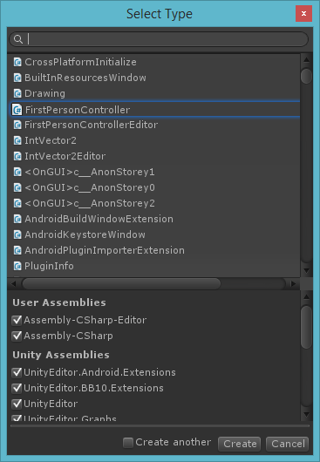

This window is used to pick the type that you want to create your Editor for. There is a text field at the top that lets you filter the results to find that type that you are looking for. You can also filter the Assemblies by using the check boxes at the bottom.

If you would like to create more than one Editor click the Create another check box. This will keep the window open after you hit create.

Once you have the top selected click Create and a new window will pop up asking where you want to save your new file. Choses a location and hit save. Jiffy will now look at the type you sent it and generate an Editor for you. That is it, you are done.

**You can also use the Create Menu to make an editor. Right click on a script and click Create/Editor or** Create Property Drawer. This will then pop up a window asking where you would like to save the script. Choose a path and click save. The project will now recompile and your new editor script will be pinged.

